Date: 12.03.2021
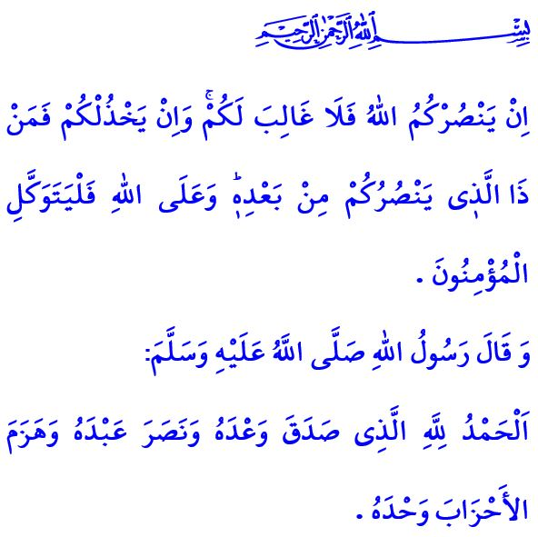
INDEPENDENCE MARCH (Turkish National Anthem): Independence is the absolute right of my nation who worships al-Haqq!

Honorable Muslims!
Allah the Almighty (swt) states in the verse I have recited, “If Allah should aid you, no one can overcome you; but if He should forsake you, who is there that can aid you after Him? And upon Allah let the believers rely.”
The Prophet Muhammad (saw) says in the hadith I have recited, “Praise is to Allah who has fulfilled His promise, granted victory to His slave, and defeated confederates of enemy alone.”
Dear Believers!
A hundred years ago, we put up an all-out fight for existence. We all, together as men and women, young and old, mobilized in defence of our homeland. We sacrificed our lives, loved ones, and all our existence, but did not let the enemy’s hand touch our heavenly homeland. It was in those most challenging times of ours when our national anthem, the Independence March, was born as the representation of our unshakeable faith, resolve to walk on the true path, love for the homeland, and nobility and courage in verses. This epic anthem became a seal of belonging engraved in the minds and hearts of each and every member of our nation.
Dear Muslims!
Our National Anthem reflects the spirit of the following verse, “Do not weaken and do not grieve, and you will be superior if you are [true] believers.”
Our Independence March teaches us our purpose of existence, who we are, and how we will continue to exist. It exclaims that our flag as the symbol of our independence will not be hauled down before the last hearth that is ablaze within our homeland is extinguished. It instructs that our homeland, watered by the blood of our martyrs, cannot ever be allowed to be trodden under enemy feet. It supplicates that the adhan, the testimonies of which are the foundation of the religion, may continue to echo in the skies of our homeland forever. It heralds the eternal independence of our nation with the following lines:
For freedom is the absolute right of my ever-free flag;
For independence is the absolute right of my nation who worships al-Haqq!
Dear Believers!
The 12th of March is the anniversary of the adoption of our National Anthem, and the 18th of March is the anniversary of our Çanakkale Victory. With heartfelt gratitude and indebtedness, I would like to take this opportunity to commemorate and wish Allah’s mercy upon our heroic martyrs and veterans who have borne the banner of justice, peace and security throughout the history and bequathed this heavenly homeland for us.

Al-i ‘Imran, 3/160.
Ibn Majah, Diyat, 5.
Al-i ‘Imran, 3/139. General Directorate of Religious Services

